WALMART SALES
PERFORMANCE DASHBOARD REPORT
Power BI Sales Analysis using Walmart Weekly Sales Data

Project Report Submitted By
Name: Athira S
Tool Used: Microsoft Power BI Desktop

Introduction
This project presents an interactive Walmart sales performance dashboard developed in Microsoft Power BI. The dashboard converts weekly store-level sales data into a set of visual summaries that can be explored through filters and drill-through pages. The report focuses on store performance, sales movement over time, holiday versus non-holiday sales, and the relationship between fuel price and weekly sales.
The dashboard is designed to make a large sales dataset easier to interpret at a glance. Instead of relying on a static table, the report combines KPI cards, column and bar charts, a time-series line chart, a scatter plot and a donut chart so that different aspects of performance can be viewed together.

Objectives
- Analyze weekly sales performance across all 45 Walmart stores.
- Create an interactive Power BI dashboard rather than a static report.
- Compare sales during holiday weeks with regular weeks.
- Track how total sales change across the reporting period.
- Explore whether fuel-price variation appears to move with weekly sales.
- Compare average sales between individual stores.
- Provide drill-through views for detailed store, date, factor and holiday analysis.

Dataset Description
The dataset used in the dashboard contains weekly Walmart store sales records. The visible project documentation identifies the main fields as Store, Date, Weekly Sales, Holiday Flag, Temperature, Fuel Price, CPI and Unemployment.
Field | Meaning | Use in Dashboard
Store | Store identifier (1–45) | Store-level comparisons and drill-through
Date | Week in which sales were recorded | Time-series trend and date filtering
Weekly Sales | Sales value for a store-week | Main sales measure and KPI calculations
Holiday Flag | 0 = regular week; 1 = holiday week | Holiday comparison and slicer
Temperature | Regional temperature | Available contextual factor
Fuel Price | Regional fuel price | Scatter-plot factor comparison
CPI | Consumer Price Index | Economic context
Unemployment | Regional unemployment rate | Economic context

The dataset structure shown in the project documentation is consistent with the commonly published Walmart sales dataset containing Store, Date, Weekly Sales, Holiday Flag, Temperature, Fuel Price, CPI and Unemployment.

Data Preparation
- Imported the Walmart sales data into Power BI Desktop.
- Checked and corrected the Date field so it was interpreted as a proper date.
- Verified that Weekly Sales, Fuel Price, CPI and Unemployment were treated as numeric fields.
- Used Store and Holiday Flag as categorical dimensions for visual comparisons and filtering.
- Prepared the report pages and drill-through views so users could move from the summary dashboard to individual visual analyses.

DAX Measures Used
The dashboard uses simple measures to calculate the KPI values dynamically. Measures recalculate according to the current filter context, which allows the KPI cards and visuals to respond to selections made through the slicers.
Measure | Purpose
Total Sale = SUM('Walmart'[Weekly Sales]) | Calculates total sales in the current filter context.
Average Sale = AVERAGE('Walmart'[Weekly Sales]) | Calculates the average weekly sales value.
Store Count = DISTINCTCOUNT('Walmart'[Store]) | Counts the number of unique stores represented.

Dashboard Overview
The main dashboard brings the analysis together on a single page. Three KPI cards show store count, average sale and total sale, while the lower visuals examine store performance, sales over time, fuel price versus sales, holiday status and average sales by store.

SLICERS
Store • Date • Holiday Status

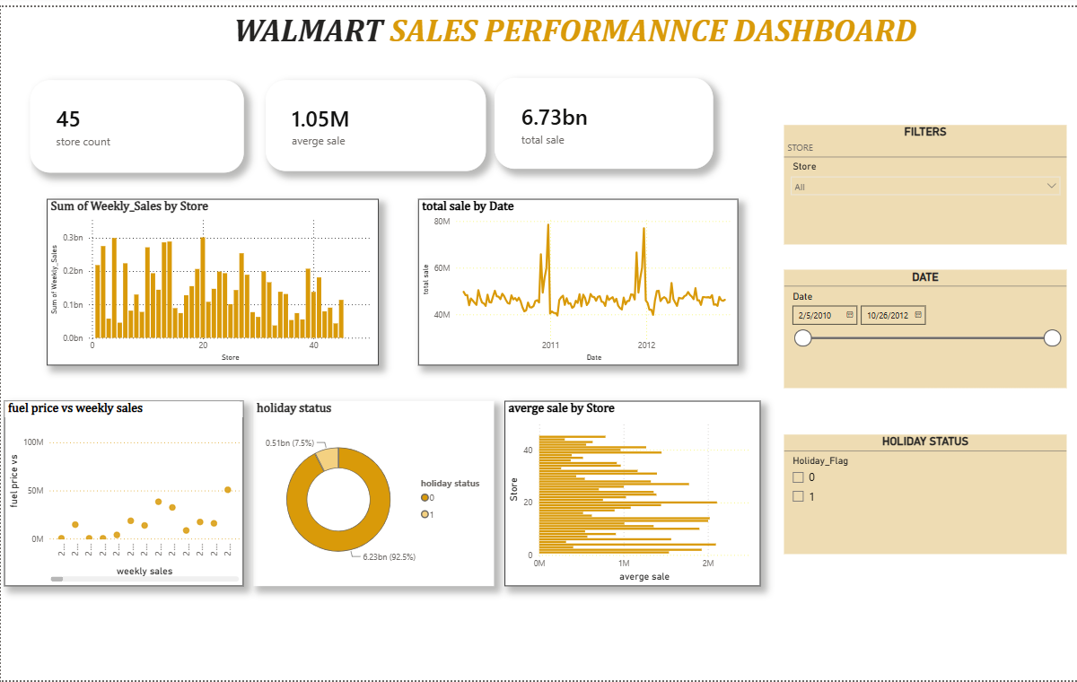

Key observations
- The dashboard covers 45 stores.
- The displayed average sale KPI is approximately 1.05M.
- The displayed total sale KPI is approximately 6.73bn.
- Store, Date and Holiday Status slicers allow the user to narrow the analysis interactively.
- The dashboard combines summary KPIs with five complementary visual perspectives.

Weekly Sales by Store
SLICER / FILTER CONTEXT
Store • Drill-through from the main dashboard

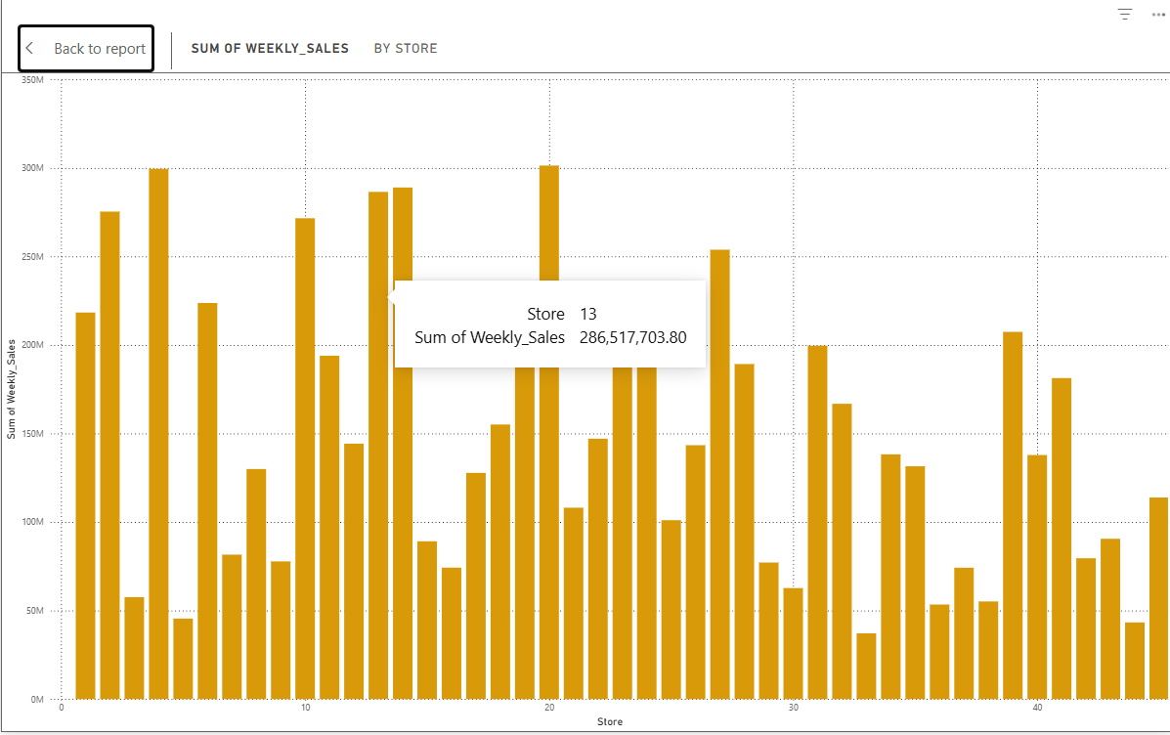
The column chart compares the sum of Weekly Sales across the 45 stores. The large differences in bar height make it easy to identify stores with comparatively stronger or weaker cumulative sales performance.

Key Findings
- Sales are not evenly distributed across the 45 stores; several stores show substantially higher cumulative sales than others.
- The drill-through example highlights Store 13 with cumulative Weekly Sales of approximately 286.52M.
- The dashboard can be used to select a store and move to a focused view without losing the overall report context.

Total Sales by Date
SLICER / FILTER CONTEXT
Date • Time-period filtering

The line chart tracks total sales across the reporting period. The chart shows a relatively stable band of weekly sales with occasional sharp peaks, making it useful for identifying unusually strong sales weeks.
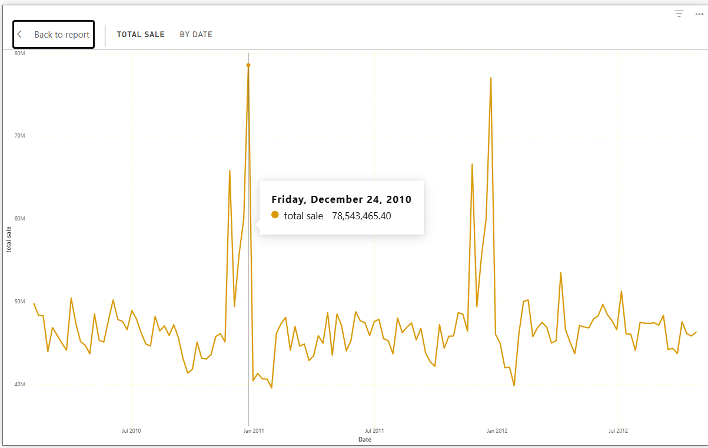

Key Findings
- A prominent peak occurs around the end-of-year holiday period.
- The highlighted 24 December 2010 point shows total sales of approximately 78.54M.
- Another major spike appears around the 2011–2012 transition, indicating strong seasonal variation.
- The line chart is useful for monitoring changes over time and identifying periods that may require further investigation.

Fuel Price vs Weekly Sales
SLICER / FILTER CONTEXT
Store / Date context can be applied through the dashboard; visual shown without a restrictive selection
The scatter plot places weekly sales against fuel-price observations. The points are widely dispersed rather than forming a single obvious straight-line pattern in the screenshot.
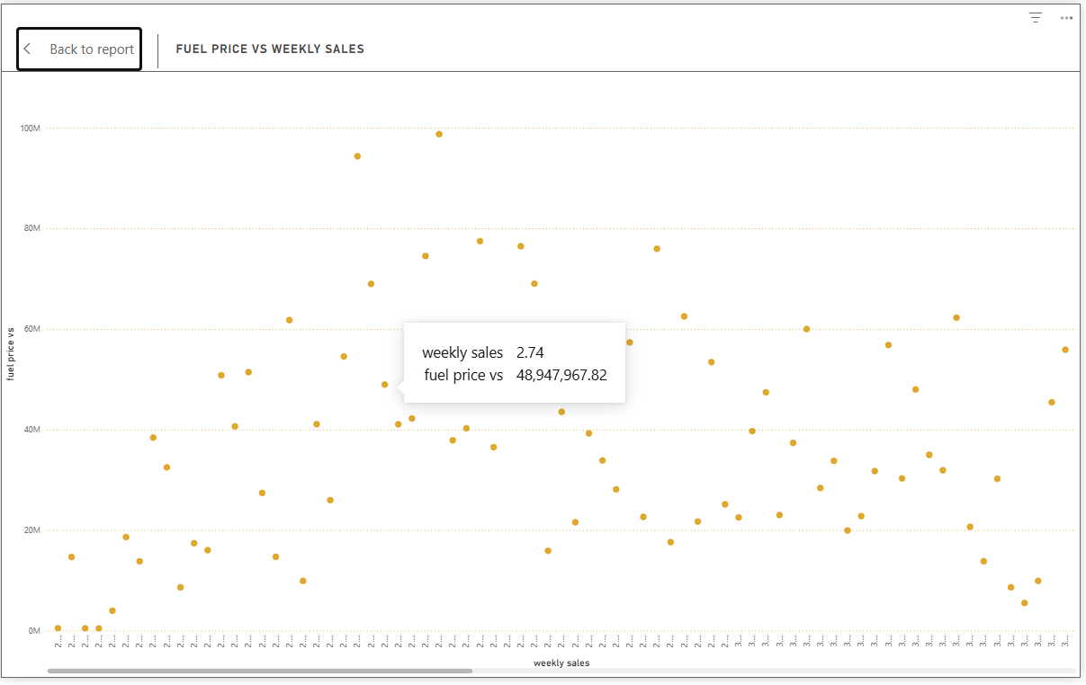

Key Findings
- The visual does not show a clear strong linear relationship by inspection alone.
- Sales values vary substantially across observations even when fuel-price observations are in similar ranges.
- A statistical correlation or regression would be required to quantify the relationship; the scatter plot itself should be treated as an exploratory view.
- The highlighted observation in the dashboard shows a weekly-sales value around 2.73 and a corresponding plotted value of about 68.97M in the tooltip.

Holiday Status
SLICER / FILTER CONTEXT
Holiday Status • Holiday Flag (0 / 1)
The donut chart compares total sales recorded during regular weeks and holiday weeks. Holiday_Flag 1 represents holiday weeks, while 0 represents non-holiday weeks.

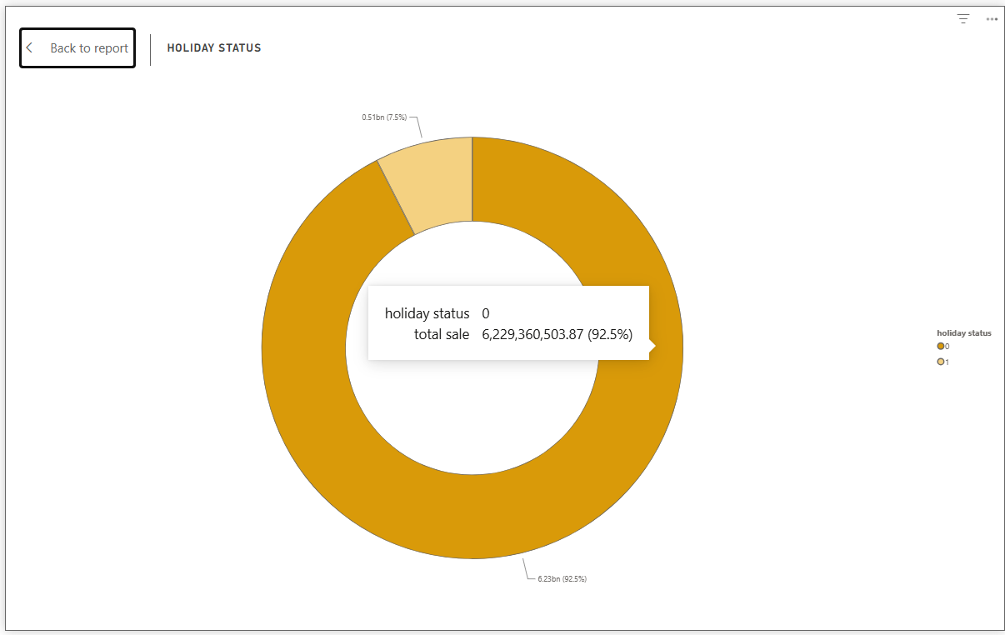

Key Findings
- Holiday weeks account for approximately 505.30M, or 7.5% of the displayed total sales.
- Regular weeks account for approximately 92.5% of the displayed sales, reflecting the much larger number of non-holiday observations.
- The chart is useful for understanding the contribution of holiday periods to overall sales, but the percentages should not be interpreted as holiday sales being less important without considering the number of weeks in each category.

7.5 Average Sale by Store
SLICER / FILTER CONTEXT
Store • Store-level comparison
The horizontal bar chart compares average weekly sales across the 45 stores. A horizontal layout makes it easier to compare many store categories while keeping the store identifiers visible.
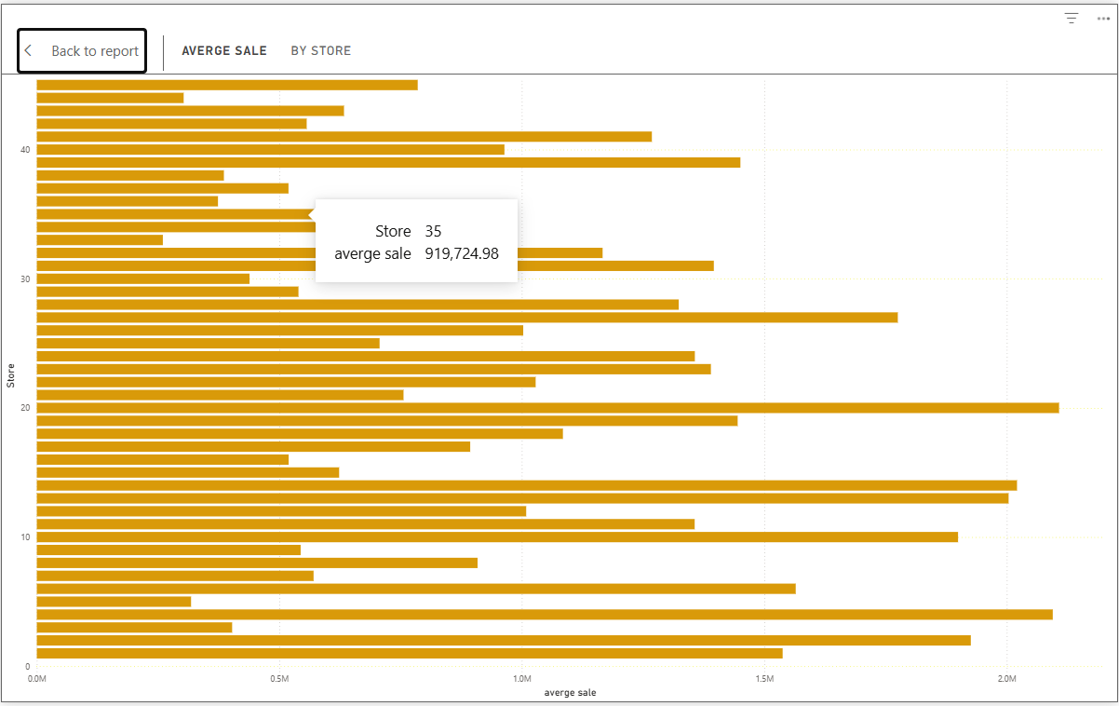

Key Findings
- Average sales differ considerably between stores, showing that store performance is heterogeneous.
- The highlighted example shows Store 40 with an average sale of approximately 964,128.04.
- The chart can support store-level benchmarking by identifying stores whose average sales are comparatively high or low.
- Combining this visual with the Store slicer allows a user to focus on a particular store and investigate its sales behavior.

8. Key Findings
Area | Finding
Overall scale | The dashboard represents 45 stores and displays approximately 6.73bn in total sales with an average sale KPI of about 1.05M.
Store variation | Cumulative and average sales vary materially between stores, indicating different levels of store performance.
Time trend | Sales remain within a broad weekly range but contain distinct spikes, particularly around holiday periods.
Holiday contribution | Holiday weeks represent about 7.5% of displayed sales, while regular weeks represent about 92.5%.
Fuel-price view | The scatter plot does not visually indicate a strong simple linear relationship between fuel price and weekly sales.
Interactivity | Store, Date and Holiday Status slicers make the dashboard useful for interactive exploration rather than one-time viewing.

Conclusion
The Walmart Sales Performance Dashboard successfully converts weekly store-level sales data into an interactive Power BI report. The combination of KPI cards, store comparisons, time-series analysis, a factor comparison, holiday analysis and drill-through pages provides a clear view of sales performance.
Overall, the dashboard shows meaningful variation between stores and noticeable seasonal peaks in sales. The slicers improve usability by allowing the viewer to examine the data by store, date and holiday status. For a stronger analytical conclusion about fuel price or other external factors, the dashboard could be extended with correlation coefficients, regression analysis or additional economic and store-level variables.

